***Electric Force Problems***

1. Find the net force on charge q 1 due to the three other charges in figure1. Take q1= -5μC , q2 = -8 μC, q3 = 15 μC and q4 = - 16 μC , a= 5cm. (2.3 I – 2.4j)

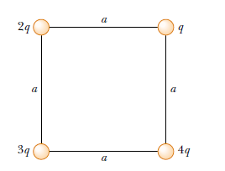 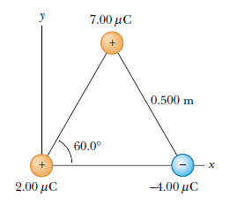

Fig-1 Fig-2

1. Three point charges are located at the corners of an equilateral triangle, as shown in Figure -2 . Calculate the net electric force on the 7 μ C charge.
2. A point charge q1 = - 9 μC is at x=0 , while q2= 4μC is at x=1 m. At what point, besides infinity, would the net force on a positive charge q3 be zero ? (d=2m)
3. A t what separation would the force between a proton and an electron be 1 N ? (Ans: 1.52 x 10-14m)
4. In Fig. 3a, particles 1 and 2 have charge 20.0 mC each and are held at separation distance d = 1.50 m. (a) What is the magnitude of the electrostatic force on particle 1 due to particle 2? In Fig3b Particle 3 of charge 20.0 mC is positioned so as to complete an equilateral triangle. (b) What is the magnitude of the net electrostatic force on particle 1 due to particles 2 and 3? (Ans: (a) 1.6 N, (b) 2.77N)

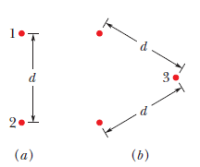 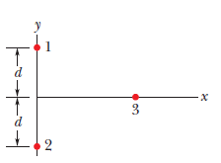

Fig-3 Fig-4

1. In figure-4 , particles 1 and 2 of chagre q1 =q2 = +3.2 x 10-19 C are on a y axis at distance d = 17cm from the origin. Particles 3 of chagre q3 = + 6.4 x10-19 C is moved gradually along the x axis from x=0 to x=+5m. At what vlaues of x will the magnitude of the electrostatics force on the third particles from the other two particles be (a) minimum and (b) maximum?

( Ans: (a) 0 (b) 12cm)